React Native Expo Project
Progress Log
Student Name: ____Katellyn Hyker____________________________________
App Name: ______InnerBloom__________________________________

Progress Made

Added daily reflection prompt
Added search bar functionality to journal
Made small changes to clean up some looked over errors (such as ViewEntry not being scrollable to account for long entries)
Started preparing for log in and user handling
Design Updates
Include screenshots or images of your app screens below.
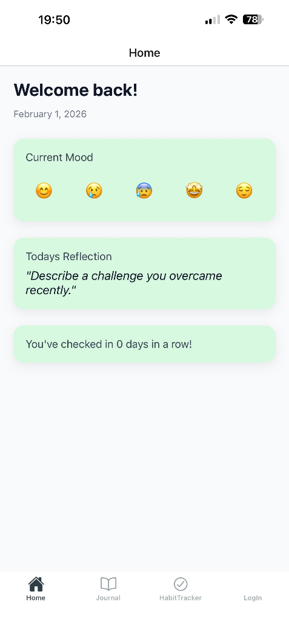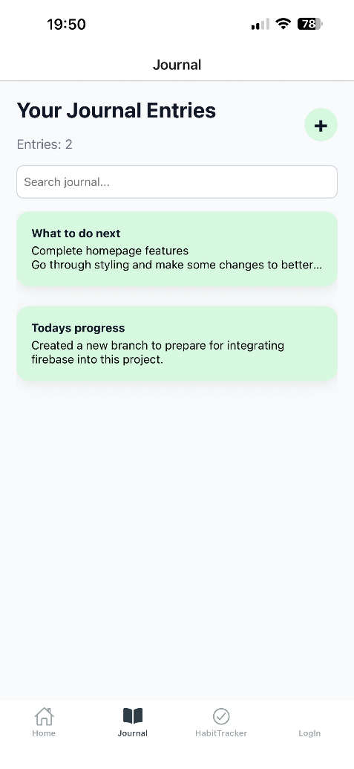
Issues / Blockers

No new issues.
Main blockers:
Trying to figure out how to best manage displaying creation dates on entries
Trying to think of how to adjust habit and entries data to be saved per user

Next Steps

Complete Login/signup functionality
Adjust database to fit with per user idea
Create Testing code

